7th edition
1 and 2 Highlights for our learners
HIGHLIGHTS OF TERM 1 AND 2

This year has already brought many exciting opportunities for all of our learners. They have been working hard in the classrooms and on stage as well. In this edition we take a look at what has been happening at our school…
Class captains:

Some learners have worked especially hard and have been chosen to become Captains of their classes already! Each class in our school has their own Class Captain. We want to say congratulations to all of these learners! Let’s encourage all our learners to do their best, be kind, work hard and help their fellow classmates. We look forward to seeing who our next Captains are.
Merit badges:

Many learners have also received Merit badges for their efforts at school. These are awarded for achievements such as:
- Good behavior
- Excellent work in class
- Good progress
- Good behavior
- Helpfulness
- Kindness to others
Different colour badges are given according to how many merit points a learner has earned. We congratulate these learners for their Merit Badge awards and look forward to seeing many more names added to this list.
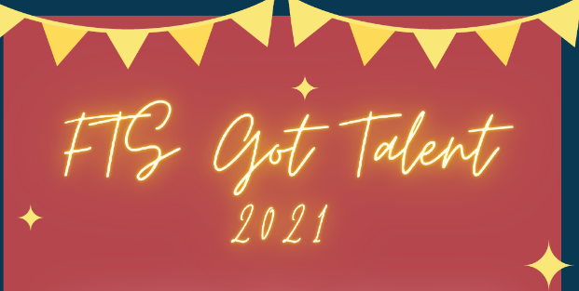

Forest Town’s Annual Talent Show Auditions are happening right now and is giving our learners the chance to showcase their singing, music or acting talents. We have already seen so many amazing acts perform on stage, with all Covid-19 regulations observed. Well done to all who have entered and we look forward to seeing the rest of the auditions this week and the Finals coming up later this term!
SANTAM
Wish Upon a Star
Art Competition

SANTAM Wish Upon a Star
Art Competition

SANTAM Insurance is running an art completion for all learners ages 5 years and over around the country. Entry forms and details are attached to this Newsletter if you would like to enter. Entries need to be sent via post to their company, and arrive, by end June 2021. This is a great opportunity to highlight t our learners creative and artistic talents

And lastly….
We would love to hear positive stories from our learners about:
- their experiences at school such as the skills, activities, events or subjects they are involved in

If your child would like to share these with our learners, parents and staff through the KIDS POST NEWSLETTER, please contact Lynndall on lynndalle@fts.org.za or via school telephone line 011 646 0131 Monday-Friday after 1:30pm. Please encourage your children as we would like this newsletter to be about and for our learners, celebrating all they are and do!
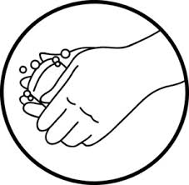
1,5m
Stay safe: Wear a mask, wash and sanitize your hands and social distance

