9th edition
1 and 2 Highlights for our learners
HIGHLIGHTS OF TERM 3

WOW what a term our learners have had! Our learners at Forest Town School have been involved in many exciting activities in and around our school. We would love to hear positive stories from our learners about their experiences at school such as the skills, activities, events or subjects they are involved in. If your child would like to share these with our learners, parents and staff through the KIDS POST NEWSLETTER, please contact Lynndall on lynndalle@fts.org.za or via school telephone line 011 646 0131 Monday-Friday after 1:30pm. Please encourage your children as we would like this newsletter to be about and for our learners, celebrating all they are and do!
here are some of the highlights from this term:
Class captains:
Merit badges:

Congratulations to all of the learners who became class captains this term! Your hard work and responsible attitudes have led to your achievement. Families at home, please keep encouraging your child to always do their best, be kind, work hard and help their fellow classmates. We look forward to seeing their names as our future class captains.

Well done to all the many, many learners who have achieved their merit badges this term!
Keep up your hard work.

Keep reading for more….
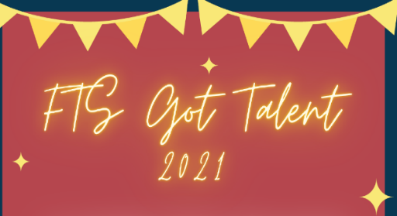

Well done to all the finalists who went through to the finals of our talent show this term! Amazing performances in dance and song were given by all and we could not be prouder of all the participants! A special CONGRATULATIONS to:
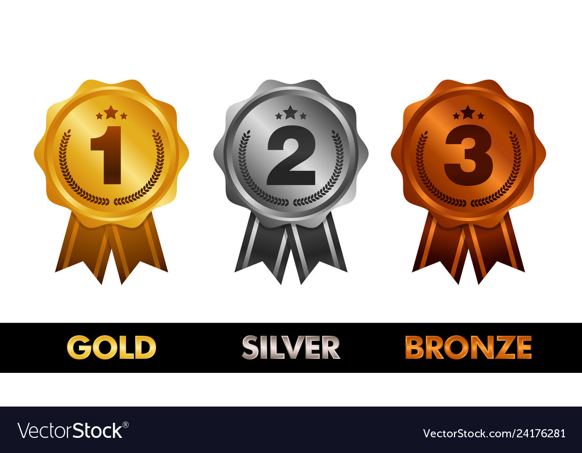 1. APHIWE C. (WEP) 2. LETLHOGONOLO N. (INTERSEN) 3.CHLOE C. (WEP)

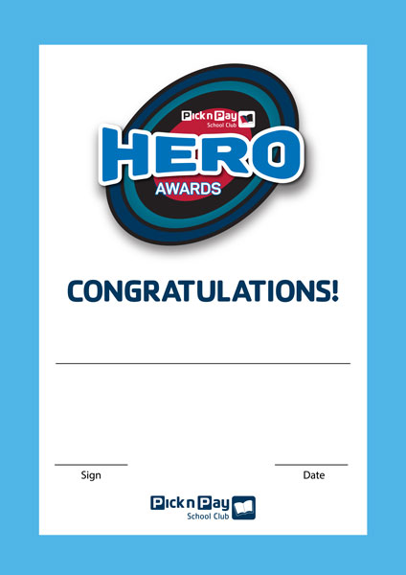
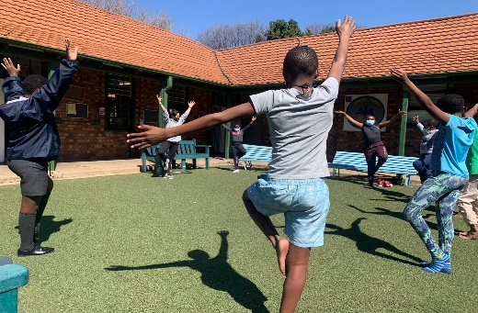
Well done to Thomas VW and Nhlanhla M. on becoming Pick N Pay Heroes this term! Your helpful natures and caring attitudes make you heroes in our eyes too!
YOGA
Some of our learners were able to participate in YOGA sessions…time to stretch and refresh!

SKATEISTAN
Some of our senior modified learners were offered the opportunity to learn the basics of skateboarding..great fun and much learning has been had by all involved!

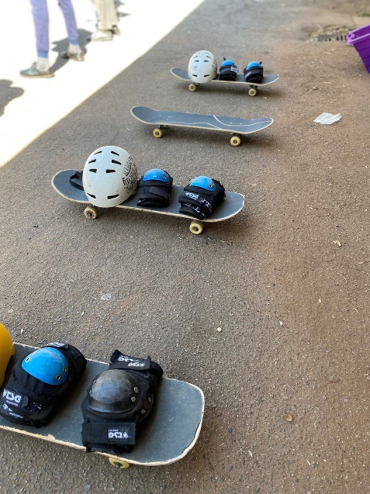

Our learners have also been working hard in class. Here are some of the projects they have been involved in:

Learning about our bones with Grade 4’s

Fantastic designs with our Grade 7’s!

Sewing skills with Busi’s WEP learners:
This project has been ongoing throughout this, and last year. We have seen some amazing creations come out of of this and great skills developing in our learners…here is a little more about this:
The main goal :
✔️Equip learners with basic sewing skills and understanding essential principles necessary to perform tasks using relevant sewing materials, tools and equipment
Progress:
We started doing hand sewn projects, for example: pin cushions,
Learners were then introduced to sewing machines at a later stage. Our next project was a pencil case.
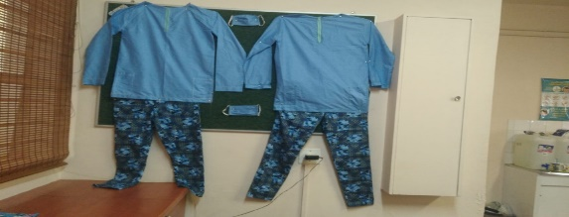
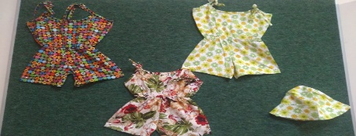
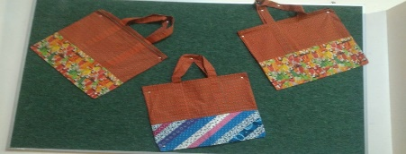
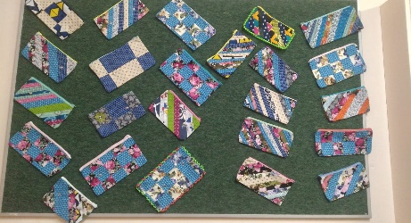
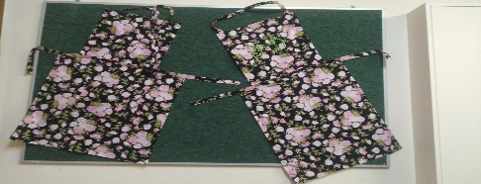
We went on to do jumpsuits, bucket hats, shopping bags, scrub tops. We kept on trying more challenging projects and learners had to sew their own out fits and back packs. They had to come up with their own designs. It was so amazing to see them being so creative. Below we can see some of their beautiful creations!

