

**7th edition**

**2021**

**Preparing our learners to return to school**

We have had a long holiday and for some it was a good break and time to refresh. But for many it has also been a time of anxiety, sadness and stress, and our children often feel these emotions too. As we head back to school, here are some ways we can help our children deal with these emotions and prepare them to come back to school.

* **Help your child to get to know their new teachers and environments:** Many teachers will have already been in touch with parents and caregivers. Use this opportunity to ask for a photo of the teacher and their classroom. Show these to your child and explain to them who their teacher will be. Talk about what they can see in their new classroom
* **Talk to them about their feelings:** Children have many feelings that they may find difficult to understand and express. Open up a conversation with them by asking questions such as-
* Are you excited to go back to school?
* What scares or worries you about going back to school?
* Who are your friends at school?
* What do you enjoy doing at school?

Watching and reading stories, or using pictures, about going to school can help them feel more prepared.



* T**each and practice routines at home:**

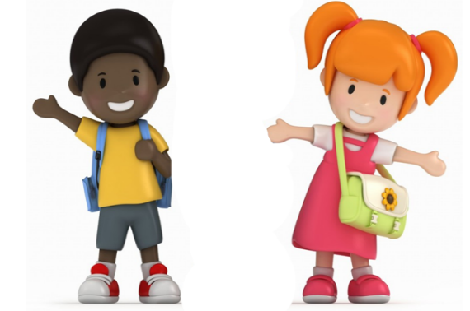

1,5m

* Wearing masks
* Social distancing
* Waking up and going to bed early
* Doing some school based activities

for example: spelling, practicing letters or numbers

* Count down the days until school starts on a calendar
* Get them involved in preparing the things they will need for school. At home they could help pack their schoolbag, lunchbox and laying their clothes out
* Washing their hands correctly

